Name: Ryan Woodward, 100201137

Exercise 1 [5 marks]

- Start the “TCP/IP” (reliable connection simulator) applet.
URL : http://faculty.mc3.edu/pvetere/Applets/APPLETS/TCPIP/applet_frame.htm

- In the textfield labeled “Your message:”, type the following:

Computer networking is essential in our world today.

Then press the button “Send a message.”

- Watch the entire sequence of packets that are sent for the sample message.
  - How many DAT packets were sent?
    - There were 6 DAT packets sent
  - How many ACK packets were sent?
    - There were 6 ACK packets sent

DAT means DATA
ACK means acknowledgement
DATA <dest><seq><checksum>
Sequence always starts with 0
Packet has a limited size. Therefore, it could not accommodate all the characters.
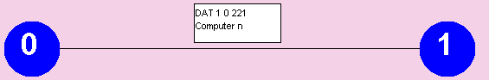

ACK <dest><seq><checksum>
Sequence corresponds to the DAT seq.
Checksum is 0 because it contains no data.
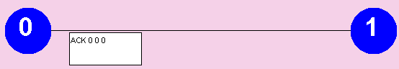

- If each character or blank in a packet header counts for one character, and all DAT packets except the last carry 10 characters, and ACK packets have no data characters (though they do have a header), count up how many characters were sent in total.

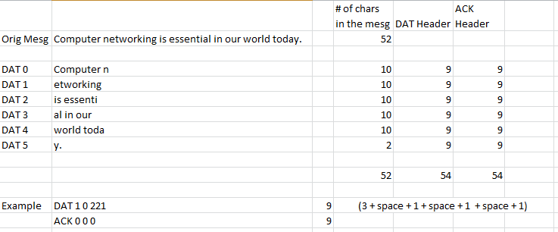

Answer: ____ characters

- There are 52 characters in the Example message, including blanks and punctuation. Subtract 52 from the total number of characters sent in both directions in all packets. (Do not damage or delete packets this time.) Divide this number by the total number of characters to get the overhead, expressed as a percentage.

Total number of characters (your answer in #4)

- Imagine that you have a million-character message to send, perhaps a large file. How many characters total would be sent in all packets necessary to move it from node 0 to node 1?

- What would be an obvious way to decrease the overhead? Why might this solution backfire? Under what conditions?

Exercise 2 [5 marks]

- Repeat Steps 1 and 2 from Exercise 1.

- Select Delete packets that are touched.

- Delete some data packets by clicking on them as they move along the wire and watch the retransmission after timeout.

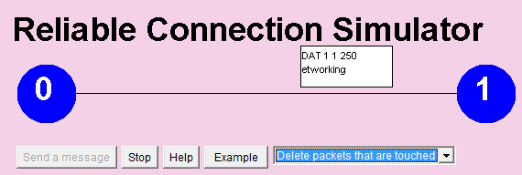
Click
And see it removed

- What happens if you delete the re-transmitted packet? Does the “TCP/IP” applet need to take any special action?

Hint: look at the message displayed in the status box

In this case the request times out and the DAT packet gets resent.

- Now try deleting some ACK or NAK packets. What happens?

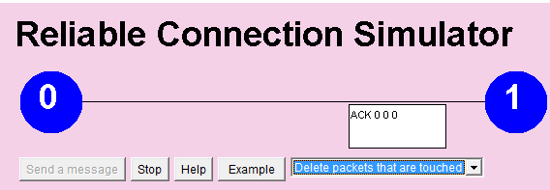
Click
And see it removed

When an ACK packet gets deleted the applet resends the original DAT packet that it did not get a receipt of acknowledgement for. The receiver recognizes that it has received a duplicate packet and resends the ACK packet.

Exercise 3 [5 marks]

- Start the “Network router” applet. Select Example 3, the ring network.

url: http://faculty.mc3.edu/pvetere/Applets/APPLETS/NETWORK/applet_frame.htm

Sample

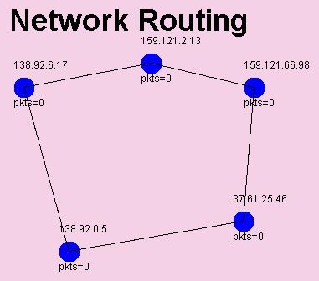

- Become familiar with the applet. Move a few nodes around by dragging them.

- Double-click on the node 37.61.25.46. List the nodes it is directly connected to.

It is directly connected to 159.121.66.98 and 138.92.0.5

- If 37.61.25.46 wants to send packets to a node that is not directly connected, to which node will it first send the packets? (Check the routing table by double clicking on the node.)

By checking the routing table it indicates that it will first send packets in the direction of 138.92.0.5

Exercise 4 [5 marks]

- Start the “Network router” applet but don’t select an example network.

url: http://faculty.mc3.edu/pvetere/Applets/APPLETS/NETWORK/applet_frame.htm

- Click on the “New Node” button four times, which will place four nodes on your screen. Move them around into a square. Then double click on node 0.0.0.1. When the edit window appears, type the IP addresses of the other nodes into the Connection Table, as shown:

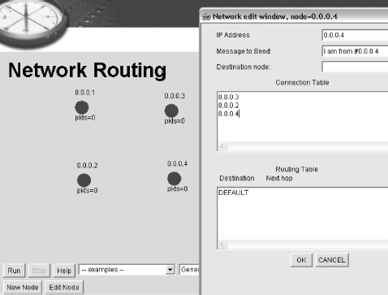

- Now edit nodes 0.0.0.2, 0.0.0.3, and 0.0.0.4. In each case, add every other node to their Connection Tables. When you are done, every node will have a direct wire to every other node:

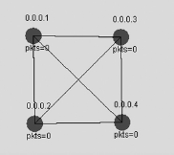

This is what is called a directly connected network. It is also called a fully connected network, for obvious reasons. Every node in the network has a direct connection to every other node. Is there a need for a routing table in this network?
In this case if any node in the network fails, there will always still be a path for each node to send information to each other.

- Sketch out below a network of 2 nodes and make it directly connected. Do not bother to assign address numbers to the nodes. Just draw circles with lines between them.

Skip

- Now sketch out a network of 3 nodes and directly connect every node.

Skip

- Fill in the table below, which compares the number of nodes in a directly connected network to the total number of wires in the network. Do not double count wires between the same nodes. That is, since there is a wire between 0.0.0.1 and 0.0.0.2, there is also a wire going the other direction, from 0.0.0.2 to 0.0.0.1. Count this as just one wire, not 2.

Number of nodes | Total number of wires
2 | 1
3 | 3
4 | 6

- Make a prediction for a 5-node network.

______10__ wires needed

- Now click on New Node to add a new node, whose number will be 0.0.0.5. Edit the other four nodes and add 0.0.0.5 to their Connection Tables. Once you are done, move your nodes around so that the nodes sit at the corners of a pentagon, as shown below. (Not all wires are shown.)

